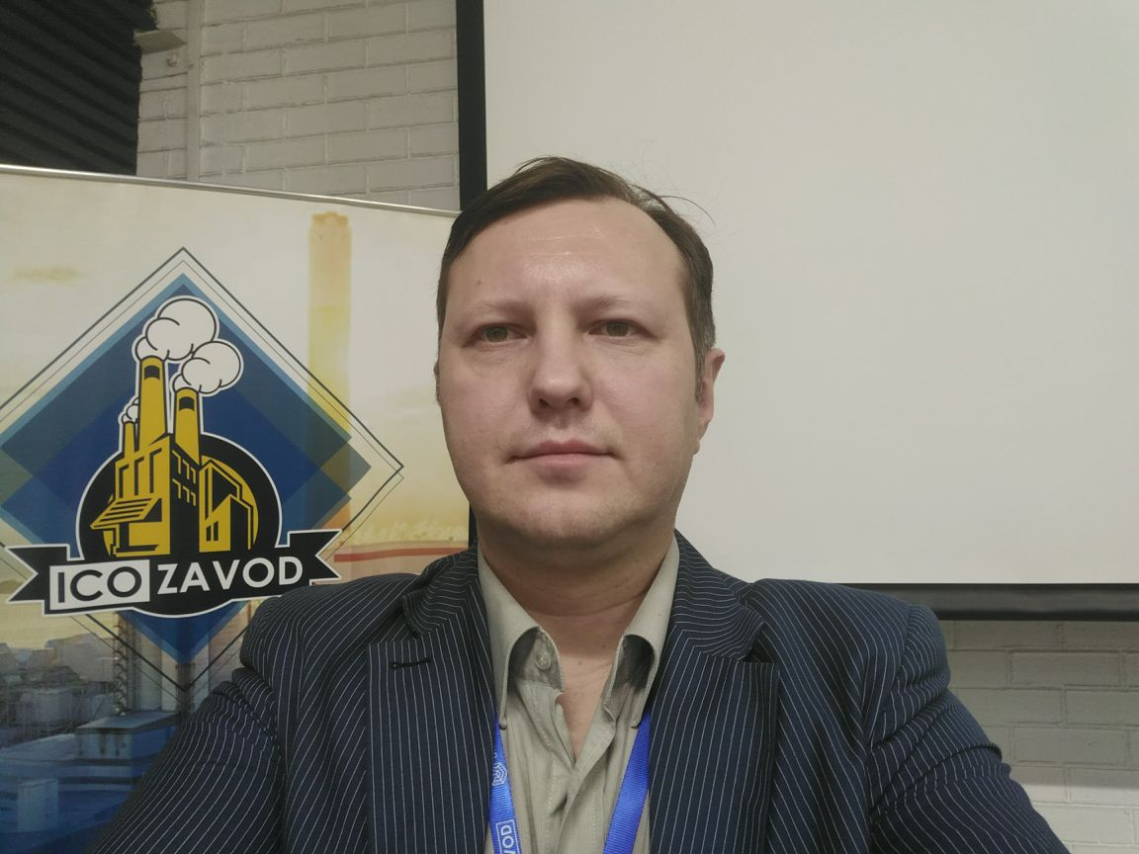 Ilya A. Shlyakhovoy  
  
Petrozavodskaya st. 24/2, Moscow, Russia

+7.9104350429 • [bulgarus@inbox.ru](mailto:bulgarus@inbox.ru)

Github: [https://github.com/bgrusnak](https://github.com/bgrusna)

**Personal Profile**

Full-stack web developer, good with PHP, Erlang, JavaScript, ActionScript, MySQL, PostgreSQL, MongoDB, with permanent desire to self-improvement.

I’m Russian citizen with EU permanent residence, can relocate to anywhere. Married with infant, my wife is Russian citizen.

**Career Objective**

To be a professional and to utilize my skills and knowledge. To invent and improve, to lead and inspire.

**Achievements**

Started webdev in the BBDO Moscow as software engineer, co-author of many russian flash sites in 2000-2008, worked in the branch of biggest russian web-studio “Art.Lebedev Group”, worked as freelancer, created the small software company for intranet solutions, last year working as JavaScript developer and project manager.

My experience includes but is not limited to the following:

Programming languages: JavaScript/Node.JS, Erlang, PHP, Python, Perl, C/C++, Delphi, Clarion, Assember, Forth, ActionScript, Java, Solidity.

JavaScript frameworks: React/Redux/Mobx, Vue/Vuex/Vuetify

Databases: MySQL, MongoDB, PostgreSQL.

Good knowledge of web technologies, including cross-platform mobile applications. Good knowledge of Telegram bot’s development.

Russian native, fluent English and Bulgarian, studying Spanish.

I have more than 4 years of project management and team management practice.

**Education and Training**

**1993 – 2000 Computer science**

**Moscow State University of Electronics and Mathematics**

Engineering degree

**Employment**

**2019(mar)-2019 (may) Frontend Team Lead SQVR.ru**

Lead the development process of the frontend in the project sqvr.ru. Our team used graphql, react and cerebral for UI.

**2018(jun)-2019 (feb) Lead JavaScript developer Iconic Ltd**

Development of some startup projects with Node.JS and Ethereum.   
Creation of blockchain-based solutions for electronic document management.   
Writing smart contracts wth Solidity, using truffle.   
Using web3 for the interaction with client-side Node.JS.

Creation of the Node.JS-based uniform REST/Websocket backend with MongoDB interaction.

**2018(jan)-2018(jun) Freelance**

Some freelance jobs. Developed cryptocurrency exchange as Telegram bot using Erlang & PostgreSQL.

**2017(nov)-2018(jan) Lead JavaScript developer Ridero Ltd**

Development of microservices for the Ridero epub services, using Docker for deployment of the application.

**2017(jul)-2017(oct) PM and JavaScript developer PharmHub Ltd**

Project management and part-time frontend web development (Angular, Node.JS) for russian startup PharmHub. Worked as manager for the team of 8 developers and testers.

**2017(jan)-2017(jun) JavaScript developer Loqus Fleet LLC**

Development of web UI in the team for the major logistics company. Used React+MobX, axios for backend interaction.

**2009-2016 Owner and CEO BulgaRus BG**

Management of the small own software development company with 4 developers. Developed custom web and offline software solutions. Best of the developed projects was the full system for the payment kiosks, including UI and the integration with third-party providers, and a lot of financial data analytics backend applications.

**2006-2009 Web developer Freelance**

Freelance web-dev, PHP backends, HTML/JavaScipt frontends

**2004-2006 Web developer**

**TeleType web studio (part of Art.Lebedev web group)**

Development of backends and Flash frontends

**2002-2004 Web developer** **TMU Consulting**

Development of Flash frontends

**2001-2002 CTO Teleport internet club**

Administrative and technical control

**2000-2001 Software developer BBDO Moscow**

Development of backends and Flash frontends

**Skills**

|  |  |  |
| --- | --- | --- |
| * React/Redux/Mobx * Vue.js * GraphQL * Node.JS * JavaScript * Erlang/Otp * PHP * MySQL * PostgreSQL * MongoDB * PHP frameworks * CSS/SASS/LESS | * HTML5 * AJAX * jQuery * Machine Learning * Data Science * Perl * X86 Assembly * JSON * XML * Git/Svn version control * ActionScript | * Adobe AIR * Adobe Flex * Forth * Clarion * Delphi * Object Pascal * LAMP * Nginx * Software Architecture * Information Architecture * Project Management |

**Hobbies and interests**

Photography, reading, IPSC, bench shooting